Extended search application.

Brief functionality description

“Search Engine” page – user can be navigated here using navigation link item 3 (picture 1 below)

Item 6 shows current view state i.e which page is opened

Current page allows user to perform multiple search.

First user have to fill text box item 1 (see on the picture below) and then press “Search” link item 2.

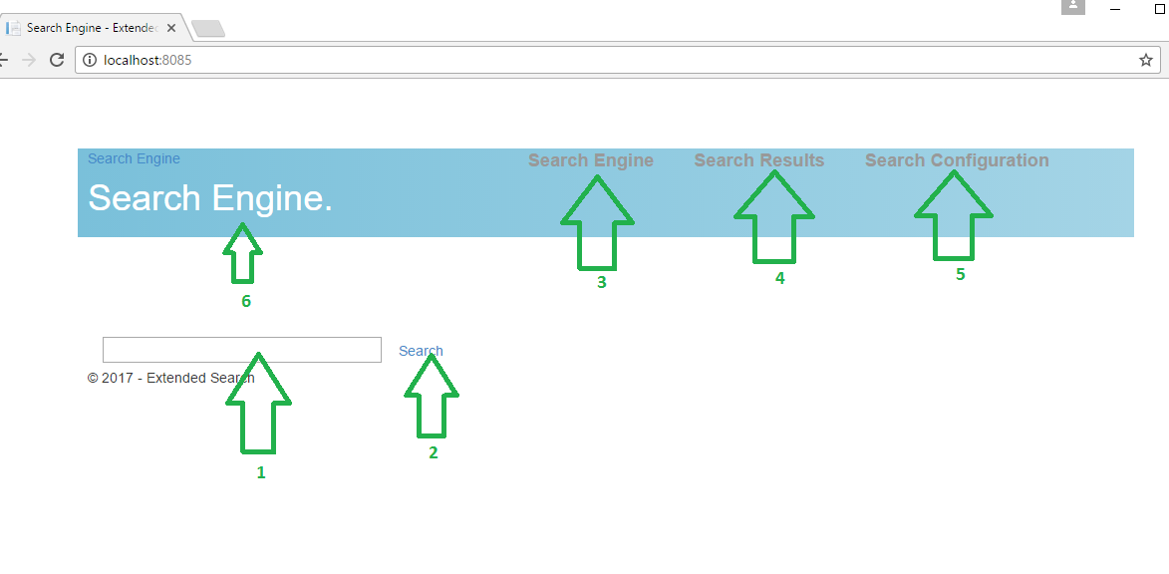

Picture 1

For example user wants to find something using searching word “murano”. See picture 2 below

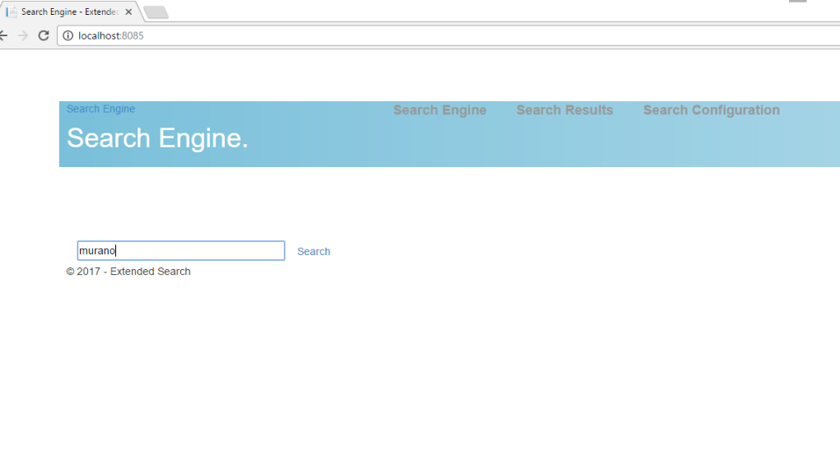

Picture 2

Next picture shows search result.

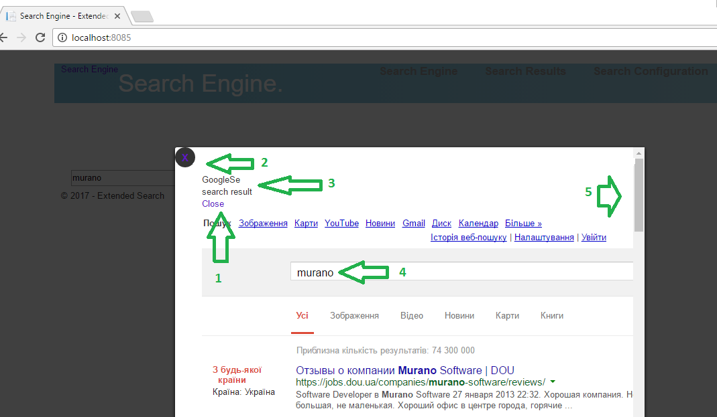

Picture 3

Searching data can be scrolled using scroller item 5.

Also Item 2 shows which word has been used to get current searching data.

Item 3 shows which search engine has returned current searching results data. This application uses predefined number of searching engines and only first that is returned required data quicker than other is showed as the result and also stored into database.

Items 1,2 is used to close current search result popup.

“Search Results” page (see picture 4 below) – user can be navigated here using navigation link item 4 (picture 1 above)

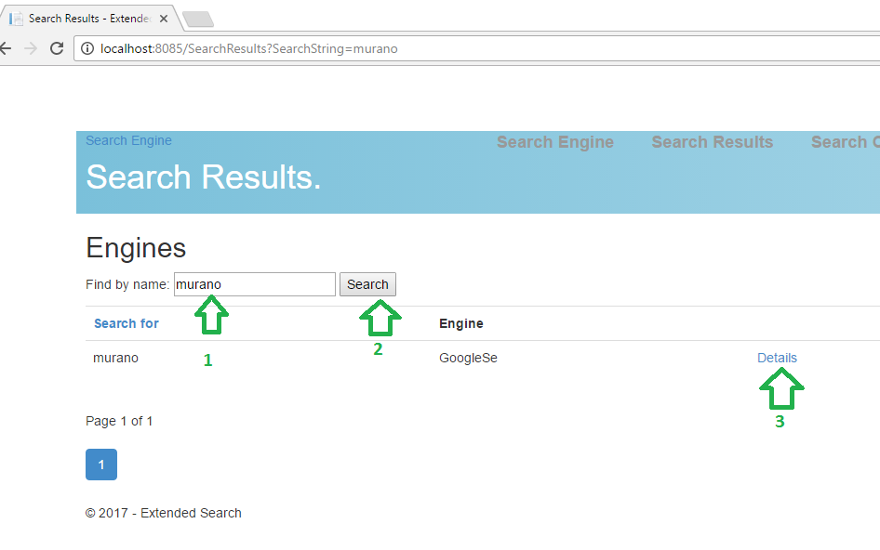

Picture 4

Here user can find and see previously searched information.

Item 1 is used to fast searching through search results.

Item 2 is used to perform search.

Item 3 is used to see searching result (see picture 5 below)

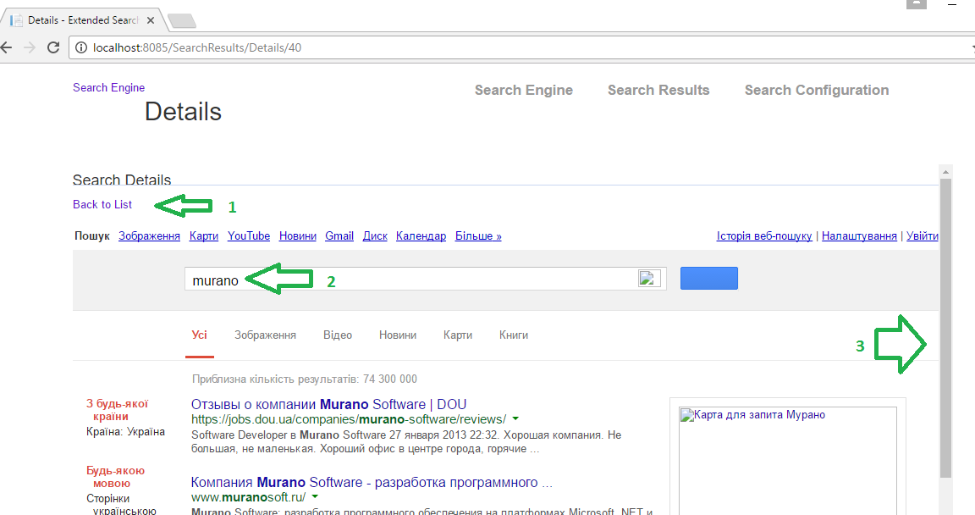

Picture 5

Item 1 is used to return back to searching results list view

Item 2 shown searching criteria

Item 3 is used to scroll searching results data info

“Search Configuration” page (see picture 6 below) – user can be navigated here using navigation link item 5 (picture 1 above)

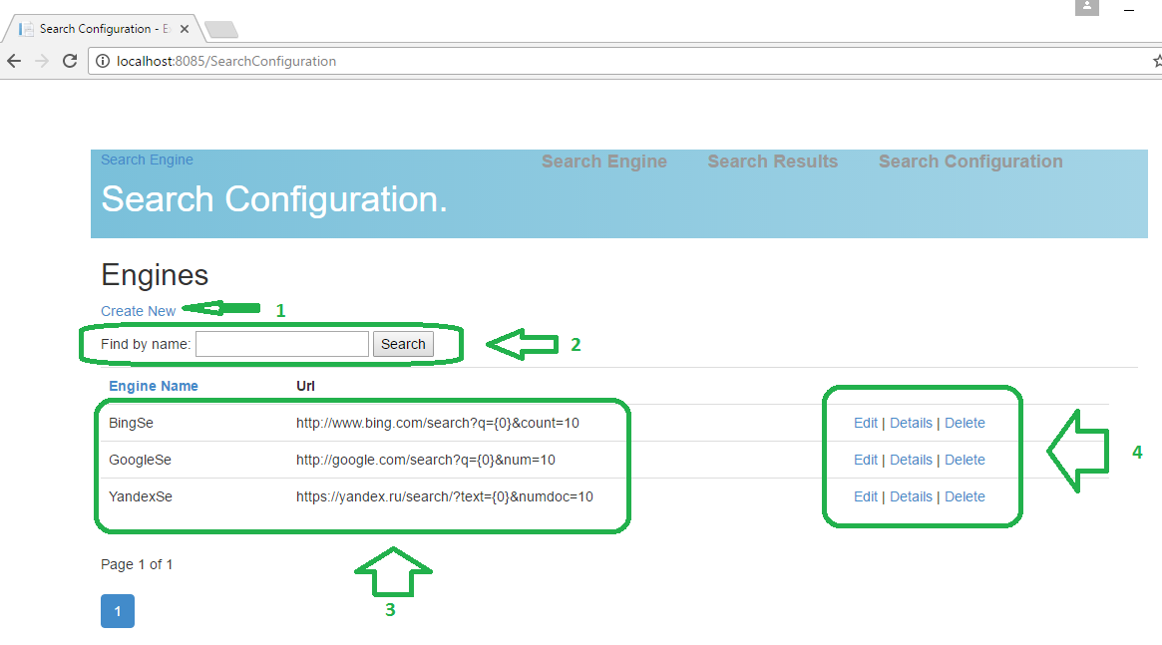

Picture 6

Item 1 - allows to add new searching engine

Item 2 – allows to find searching engine by name

Item 3 - this is search engines grid

Item 4 - each search engine can be edited, deleted and also details can be shown.

“Edit Search Engine” page (see picture 7 below) – user can be navigated here using “Create” navigation link item 1 (picture 6 above)

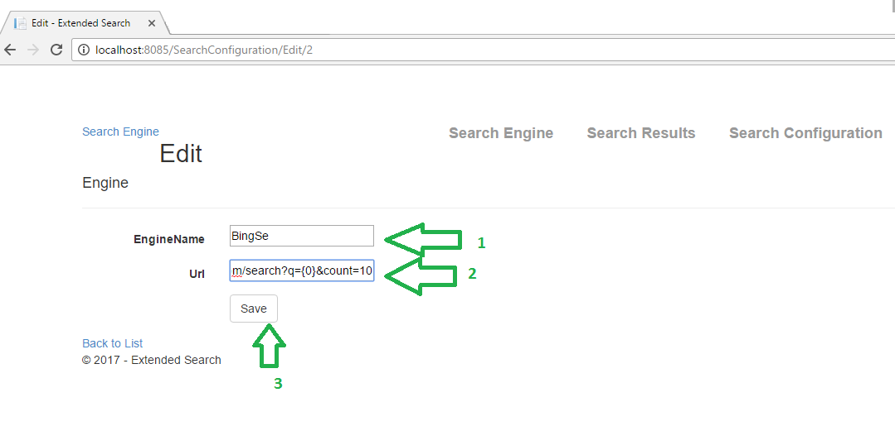

Picture 7

Item 1 - Engine name – Name of engine that is used for showing search result information

Item 2 - Engine url – this is url that is defined by search providers such as “Google”, “Bing”, “Yandex” ect.

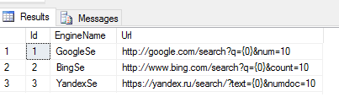

Item 3 – After this button is pressed new search engine will be used as one of possible search results data provider for main searching functionality.